Alphabetical lists
for
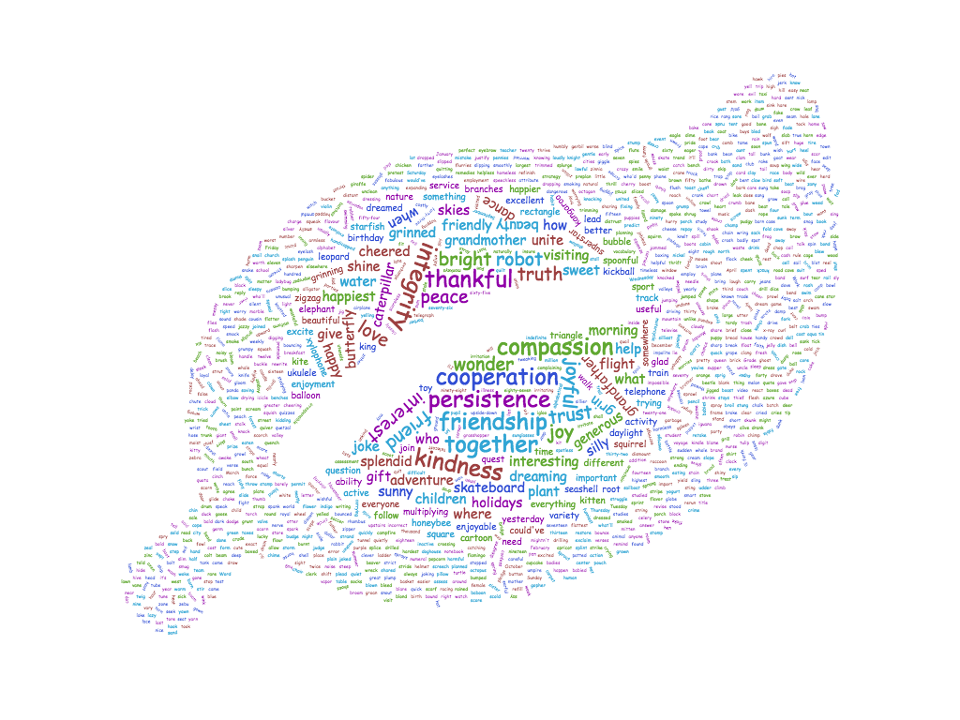
Word Work,
Expanding Vocabulary and
Writing

Grade 3

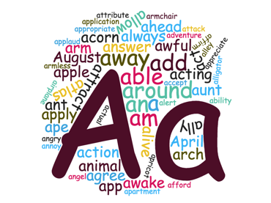
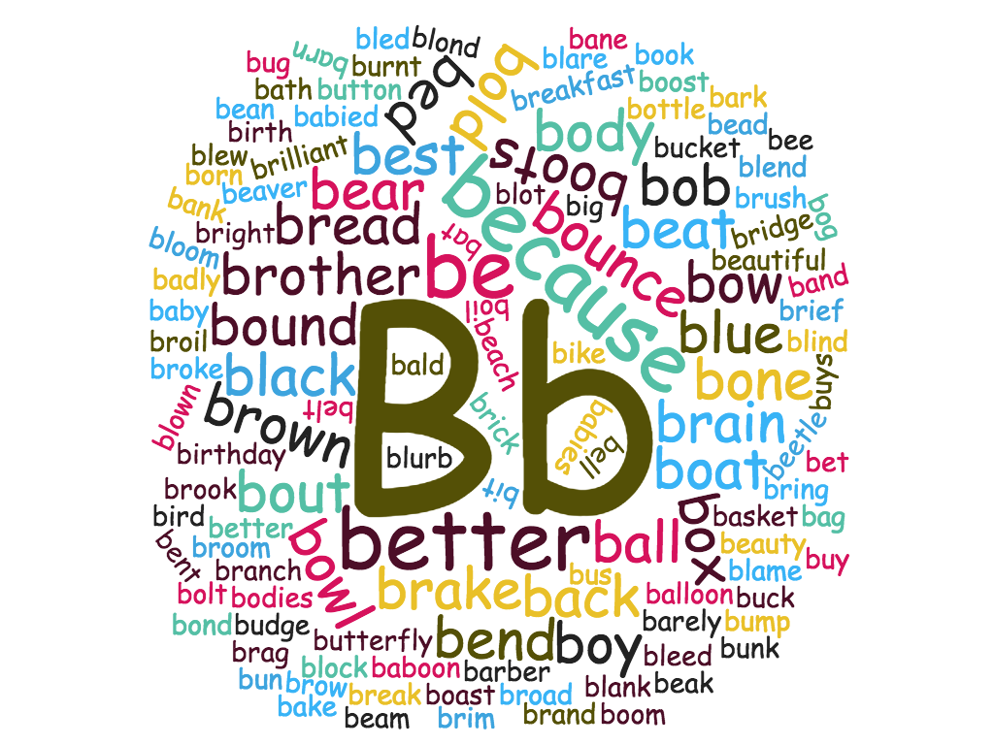

Aa
ability
across
act
active
activity
able
about
acorn
active
activity
add
addition
Africa
African
after
action
adventure
afraid
after
agree
ahead
airplane
alien
alive
alligator
allow
almost
alphabet
always
an
and
angry
animal
answer
ant
anxious
any
anyone
anything
anywhere
apricot
apple
April
aqua
arch
are
area
aren't
arm
armchair
armful
armless
assertive
at
attribute
August
aunt
average
awake
awaken
away
azure

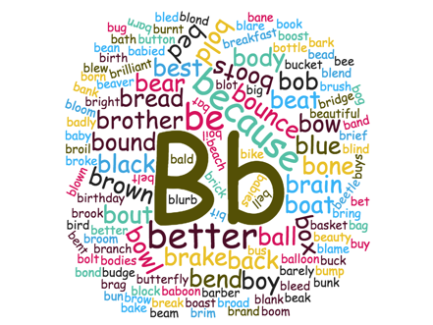

Bb
babied
babies
baboon
baby
back
badly
bag
bake
bald
ball
balloon
band
bane
bank
barber
barn
basket
bat
batch
batches
bath
bathe
be
beach
bead
beak
beam
bean
bear
beat
beautiful
beauty
beaver
bed
bee
been
beetle
bell
below
belt
bench
benches
bend
bent
best
bet
better
big
bike
bird
birth
birthday
bit
black
blame
blank
blare
bled
bleed
blend
blew
blind
block
blond
bloom
blot
blown
blue
blurb
boast
boat
bob
bodies
body
bog
boil
bold
bolt
bond
bone
book
boom
boost
bore
bored
boring
bossy
boot
boots
born
bottle
bounce
bounced
bouncing
bound
bout
bow
bow
bowl
box
boy
brag
brain
brake
branch
branches
brand
brave
bread
break
breakfast
brick
brief
bright
brim
bring
broad
bridge
broil
broke
brook
broom
brother
brow
brown
brush
bubble
buck
buckle
bucket
budge
bug
build
building
bump
bumped
bumping
bun
bunch
bunk
burnt
bus
business
busy
but
butterfly
button
buy
buys
by

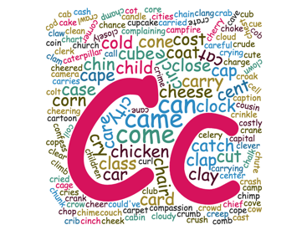

Cc
cab
cabin
Cc
cabin
cage
cake
calf
call
calm
calves
came
camera
camp
campfire
can
can't
candle
cane
cap
cape
car
card
care
careful
caring
carpet
carried
carries
carry
carrying
cartoon
case
cash
cast
cat
catch
catching
caterpillar
cave
celery
cell
cent
center
certain
certainly
chain
chair
chalk
champ
chance
charge
charm
charming
chart
cheek
cheeky
cheer
cheered
cheerful
cheering
cheese
cherry
chest
chicken
chief
child
chime
chimp
chimpanzee
chin
choke
chop
chopping
chunk
church
chute
cinch
circle
cities
city
clam
clang
claw
clay
clean
clear
clerk
clever
climb
clock
close
closely
cloud
cloudy
clown
club
coat
cob
cod
coil
coin
cold
collaborate
colour
colouring
colt
comb
combine
come
comfort
communicate
communication
compassion
compassionate
complaining
concern
concerned
conceited
conclusion
concerned
cone
confess
consider
considerate
construct
construction
coordinate
coordination
cooperative
cooperate
cop
cope
core
corner
cost
costly
cot
couch
could
could've
couldn't
courage
courageous
courageously
courrier
cousin
cove
cow
crab
crack
cracker
crane
crank
cranky
crash
crate
crawl
creep
crib
cried
cries
crime
crinkle
criteria
croak
crow
crowd
crude
crumb
crush
crutch
crutches
cry
crying
crying
cub
cube
cue
cupcake
curl
cut
cutting
cute

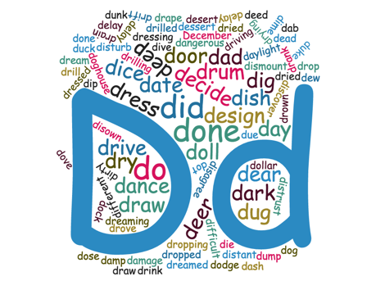

Dd
dab
dad
damage
damp
dance
dangerous
dark
dash
date
day
daylight
dead
dear
December
decide
decision
deed
deep
deer
delay
delegate
delight
delightful
deliver
demonstrate
demonstration
depend
dependable
determine
determined
dew
diagonal
dice
did
didn't
die
different
difficult
dig
digging
digit
dime
dip
dirty
disable
disagree
disagreeable
dish
dishonest
disintegrate
dismount
disown
disrespectful
distant
distrust
dive
dock
dodge
doesn't
dog
doghouse
doll
dollar
don't
don't walk
done
door
dose
dot
dove
down
drain
drank
draw
dream
dreamed
dreaming
dress
dressed
dressing
dried
drill
drilled
drilling
drink
drive
driving
driveway
drop
dropped
dropping
drove
drown
drum
dry
drying
duck
due
dug
duke
dull
dump
dunk

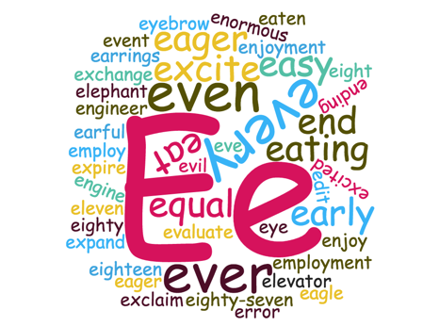

Ee
each
eager
eagle
ear
earful
early
earlier
earrings
easier
easy
eat
eating
eaten
edge
edit
eight
eighteen
eighty
eighty-seven
elbow
elephant
eleven
elf
else
elsewhere
elves
employ
employment
encourage
encouragement
encouraging
energy
energetic
end
ending
enjoy
enjoyable
enjoyment
equal
equally
equator
equip
equipment
equipped
equivalent
errand
error
evaluate
eve
even
event
ever
every
everyone
everything
evil
excel
excellent
exchange
excite
excited
exclaim
expand
exterior
ewe
eye
eyebrow
eyelash
eyelashes

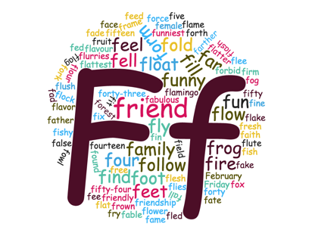
Ff

fable
fabulous
face
fad
fade
fair
faith
fake
fall
false
fantastic
fear
fearful
fearless
flamingo
false
fame
family
far
farther
fate
father
fear
fearful
fearfully
February
fed
fee
feed
feel
feet
fell
female
few
few
field
fifteen
fifty
fifty-four
fill
fin
find
fine
fire
firm
fish
fishy
fit
five
fix
flag
flake
flame
flash
flat
flatter
flattest
flavour, flavor
fled
flee
flesh
flew
flies
flight
float
flock
flour
flow
flower
flurries
flush
flute
fly
flying
fog
fold
follow
foot
for
forbid
force
forest
fork
form
forth
forty
forty-three
found
four
fourteen
fowl
fox
frame
free
fresh
Friday
fried
friend
friendly
friendship
fright
frightened
frightening
frog
frown
fruit
frustrate
frustrating
fry
frying
fun
funniest
funny
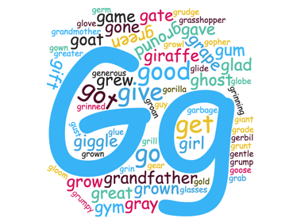

Gg

game
garbage
garden
gate
gave
gear
general
generate
generosity
generous
gentle
gerbil
germ
get
ghost
giant
gift
giggle
giraffe
girl
give
glad
glamorous
glasses
glide
globe
gloom
gloomy
glove
glue
glum
go
goat
gold
gone
good
goose
gopher
gorilla
got
government
gown
grab
grade
grain
grand
grandfather
grandmother
granny
grape
grass
grasses
grasshopper
grateful
gratitude
gravy
gray
great
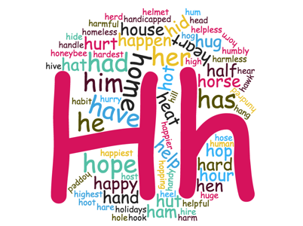
greater
green
grew
grill
grin
grinned
grinning
groan
ground
grow
growl
grown
growth
grudge
grump
grumpy
grunt
gum
gust
guy
gym
Hh
habit
had
hadn't
half
hall
hallway
ham
hammer
hand
handicapped
handle
handy
hang
hanger
happen
happier
happiest
happy
harbor
hard
hardest
hard-working
hare
harm
harmful
harmless
has
hasn't
hat
have
haven't
hawk
he
he'd
he'll
head
hear
heart
heat
heel
helmet
help
helper
helpful
helpless
hen
her
herd
here
hesitant
hesitate
hid
hide
high
highest
hill
him
hinge
hire
his
hive
hog
hole
holidays
home
homeless
honeybee
hook
hoot
hop
hope
hopeful
hopefully
hopped
hopping
horizontal
horn
horse
hose
host
hot
hour
house
how
hug
huge
hum
human
humbly
hundred
hurry
hurt
hut
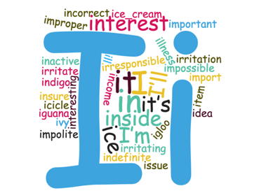

Ii
I
I'd
I’ll
I’m
I've
ice
ice cream
icicle
idea
if
iguana
igloo
ill
illness
impolite
import
important
impossible
improper
in
inactive
income
incorrect
indefinite
indigo
inning
inside
insure
integrate
integration
interest
interesting
interior
investigate
investigation
irresponsible
irritate
irritating
irritation
is
isn't
issue
it
it’ll
it’s
item
its
ivy

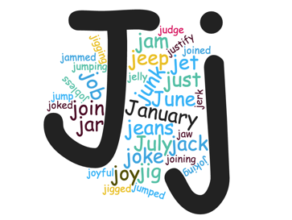

Jj

jab
jabber
jack
jam
jammed
January
jar
jaw
jeans
jeep
jelly
jerk
jet
jewel
jewelry
jig
jigged
jigging
jittery
job
jobless
join
joined
joining
joint
joke
joked
joking
joy
joyful
judge
judgment
July
jump
jumped
jumper
jumping
jumpy
June
junk
just
justice
justify

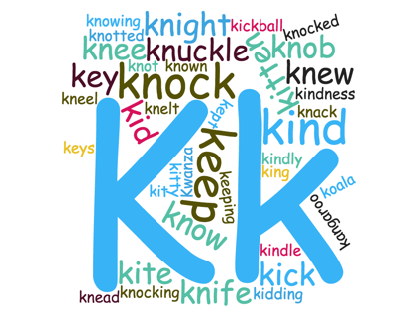

Kk

kangaroo
key
keys
kick
kickball
kid
kidding
kind
kindness
kindle
kindly
king
kit
kite
kitten
kitty
kiwi
knack
knead
knee
kneel
knelt
knew
knife
knight
knob
knock
knocked
knocking
knot
knotted
know
knowing
known

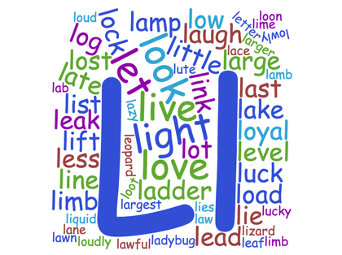

Ll

lab
lace
ladder
ladybug
lake
lamb
lamp
lane
large
larger
late
later
last
late
laugh
law
lawful
lawn
lay
lazy
lead
lead
leaf
leak
learn
leave
left
lemon
lemonade
lend
leopard
less
let
letter
level
library
librarian
lie
lies
lift
light
like
limb
lime
line
linoleum
lion
link
liquid
list
listen
little
live
lizard
load
loaf
lock
log
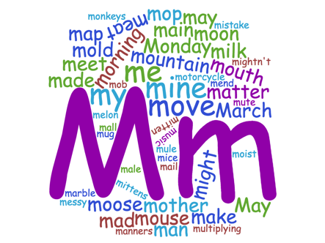
look
loud
loudly
love
low
lowly
loyal
luck
lucky
lump
lumpy
lute
lynx
Mm

mad
made
mail
main
make
male
mall
man
manage
manager
map
marble
March
mark
marker
matter
May
may
me
meat
meet
melon
mend
messy
mice
might
mighty
milk
mine
mistake
mistaken
mitten
mittens
mob
moist
mold
Monday
monkeys
moon
mop
more
morning
mother
motorcycle
mountain
mouse
mouth
mouthful
move
mug
mule
multiply
mummy
music
mustn't
mute
my

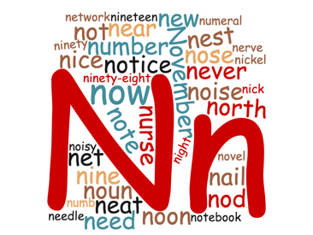

Nn

nail
natural
naturally
nature
near
nearly
neat
neatly
need
need
needle
nerve
nervous
net
never
new
nice
nick
nickel
night
nightly
nine
nineteen
ninety
ninety-eight
no
nod
noise
noisy
noon
north
nose
not
note
notebook
noun
novel
November
now
numb
number
numeral
nurse
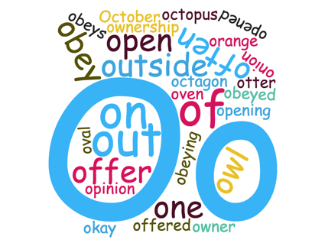

Oo
obey
obeyed
obeying
obeys
observation
observe
octagon
October
octopus
odd
of
offer
often
ogre
okay
olive
onion
one
open
operate
operation
opinion
orange
otter
our
oval
over
owl
own
owner
ownership

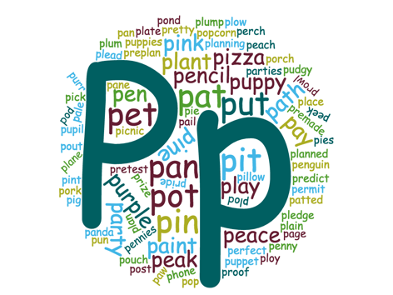

Pp

page
pail
paint
pale
pan
pancake
panda
pane
parallel
parties
party
path
patted
paw
pay
peace
peach
peak
peek
pencil
penguin
pennies
penny
perch
perfect
permit
phone
pick
picnic
pie
pies
pig
piggy
piglet
pillow
pin
pine
pink
pinkish
pizza
place
plain
plan
plane
planned
planning
plant
plant
plate
play
plead
pledge
plod
plow
ploy
plum
plump
pod
pond
pop
popcorn
porch
pork
post
pouch
pout
predict
premade
preplan
pretest
pretty
pride
prize
process
produce
proof
prowl
pudgy
pun
pun
pupil
puppet
puppies
puppy
purple
purr
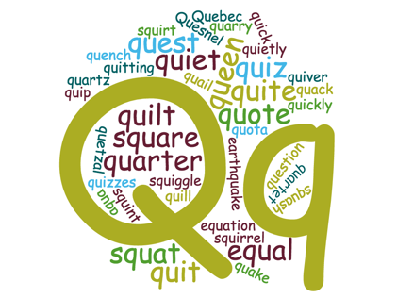

Qq

quack
quail
quarter
quartz
quench
queen
quest
question
quetzal
quick
quickly
quiet
quietly
quip
quit
quitting
quilt
quiver
quiz
quizzes
quota
quote

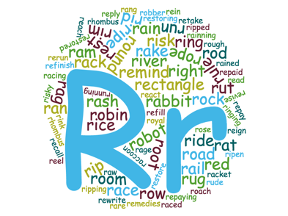

Rr

rabbit
raccoon
race
raced
racing
rag
rail
rain
rained
rake
ram
ram
ramp
ran
rang
rare
rash
rat
raw
reach
react
reaction
read
recall
rectangle
red
reddish
reel
refill
refinish
remedies
remind
repay
reply
rerun
rest
restore
revise
rewrite
rhombus
rice
rid
ride
right
rim
ring
rink
rip
risky
river
roach
road
robber
robin
robot
rock
rod
room
root
rope
rose
rough
round
row
royal
rude
rug
rule
run
running
rut

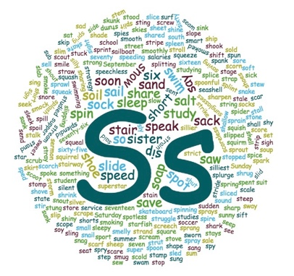

Ss

sack
sack
sad
said
sail
sailboat
stain
salaries
sale
salt
same
sand
sang
sank
sat
Saturday
saving
saw
say
scale
scar
scare
scarf
school
school crossing
scold
scoot
scope
scorch
score
scoreless
scorn
scout
scrape
scream
screech
screw
scrub
seam
seashell
seat
see
seek
seep
sell
send
sent
September
sermon
service
set
seven
seventeen
seventy
seventy-six
sew
shade
shall
shallow
shape
share
shared
sharing
shark
sharp
sharpen
she
she'll
she's
sheep
sheet
shell
shift
shine
shiny
ship
shirt
shoe
shoes
shook
short
shorts
should
shout
shove
shrink
shrug
shut
shy
sick
side
sift
sigh
sight
sign
silent
sillier
silliest
silly
silver
sing
single
sink
sip
sister
six
sixteen
sixty
sixty-five
skate
skateboard
skies
skip
skip
skirt
skunk
slab
sled
sleek
sleep
sleepy
slice
sliced
slid
slide
slim
sling
slip
slipped
slippers
slipping
slope
slow
slowly
sly
small
smart
smelly
smile
smock
smoke
smooth
smoothly
smug
snag
snail
snake
snore
snout
snow
soap
soccer
sock
socks
soft
soil
sold
solid
something
soon
sore
sound
sound
soup
south
soy
spank
spark
speak
sped
speechless
speed
spent
spice
spider
spies
spill
spin
spire
splash
spleen
splendid
splice
splint
split
splurge
spoil
spoke
spoon
spoonful
sport
spot
spotless
sprain
sprang
sprawl
spray
sprays
sprig
spring
sprint
sprout
spry
spun
spy
square
squash
squeak
squeal
squeeze
squirm
squirrel
squish
stage
stain
stale
stalk
stall
stamp
stand
star
starfish
state
stays
steep
stem
step
stew
sting
stir
stomp
stone
stood
stop
stopped
store
storm
stove
strand
strap
strategy
straw
stray
stream
street
strict
stride
strike
string
stripe
stroll
strong
struggle
strut
stuck
stuck
student
studied
studies
study
studying
stump
stung
sub
sudden
suit
sum
summer
Sunday
sung
sunglasses
sunk
sunny
super
superstar
supper
surf
swam
sway
sweet
swim
swimming
symmetry
symmetrical

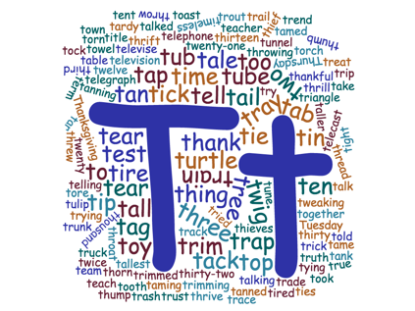
Tt

tab
table
tag
tail
take
tale
talk
talkative
tall
tame
tan
tank
tap
tar
tardy
teach
teacher
team
tear
telecast
telegraph
telephone
televise
television
tell
ten
tent
term
test
thankful
that
the
their
then
there
there's
these
they
they'll
they're
they've
thief
thing
third
thirteen
thirty
thirty-two
thorn
thousand
thread
three
thrift
thrill
thrive
throat
throw
thumb
thump
Thursday
tick
ties
tight
time
timeless
tin
tip
tire
tired
title
to
toast
tock
together
told
too
took
tooth
top
torch
tore
torn
towel
town
toy
trace
track
trade
trail
train
transfer
transport
transportation
trap
trapezoid
trash
tray
treat
tree
trend
triangle
trick
tried
trim
trimmed
trimming
trip
trout
truck
true
trunk
trust
truth
try
trying
tryout
tub
tube
Tuesday
tulip
tune
tunnel
turtle
tweaking
twelve
twenty
twenty-one
twice
twig
twin
twinkle
twinkling
two

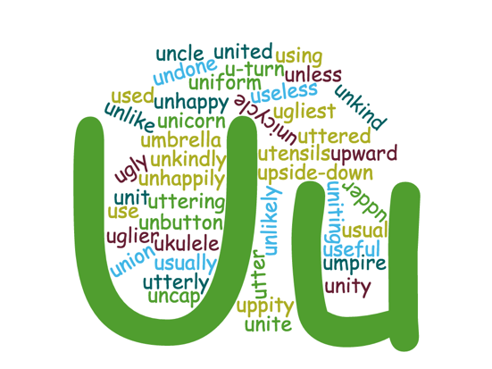

Uu

udder
ukulele
umpire
unbutton
uncle
uncertain
unclean
uncooked
independent
undone
uneasy
unhappy
uniform
union
unite
united
unkind
unlike
unsure
untie
unusual
up
upside-down
upstairs
upward
us
use
useful
usual
usually
utensils
utter
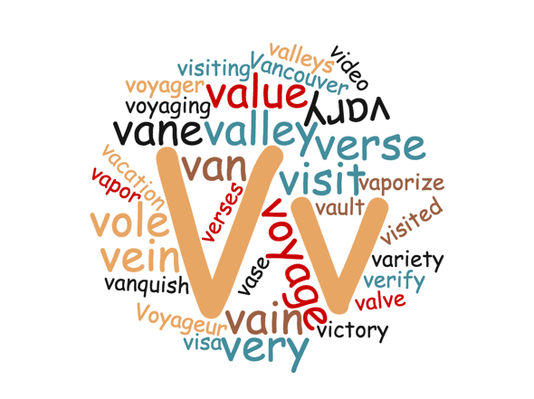

Vv

vain
valley
valleys
value
valve
van
vane
vanquish
vapor
vaporize
variety
vary
verbal
verse
verses

version
very
video
violin
visit
visited
visiting
visitor
voice
vocal
vortex
voyage

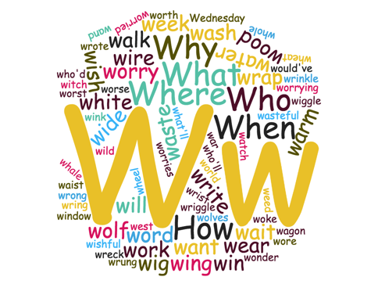

Ww
wagon
waist
wait
walk
wand
want
war
warm
wash
waste
wasteful
watch
water
we
we'd
we'll
we're
we've
wear
weave
Wednesday
weed
week
were
weren't
west
whale
what
what'll
what's
wheat
wheel
when
where
which
while
white
who
who'd
who'll
whole
why
wide
wig
wild
will
win
window
wing
wink
wire
wish
wishful
witch
woke
wolf
won't
wonder
wood
word
wore
work
world
worried
worries
worry
worrying
worse
worst
worth
would
would've
wrap
wreck
wring
wrist
write
writing
written
wrong
wrote

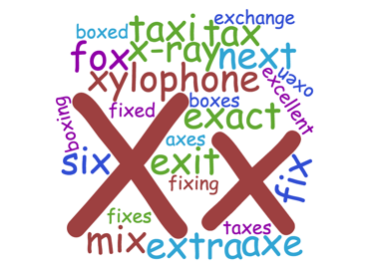

Xx

x-ray
xylophone

box
exact
excellent
excite
expand
fix
fox
mix
ox
oxen
tax
taxes
taxi

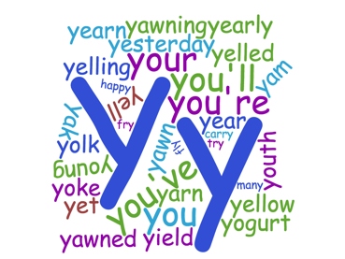

Yy

yam
yarn
yawn
year
yell
yellow
yesterday
yet
yield
yogurt
you
you’ll
you’re
you’ve
your
youth

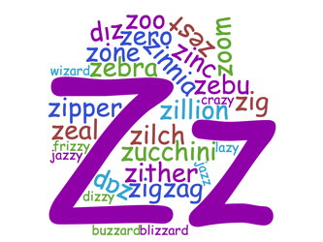

Zz

zap
zany
zeal
zealous
zebra
zebu
zig
zigzag
zillion
zinc
zinnia
zip
zipper
zither
zone
zoo

Vowels
A E I O U and sometimes Y

Some Patterns we often see: (Not all words fit neatly into patterns but these are some ideas you can try)

Long Vowel sounds:

“two vowels together, the first one says its name” (usually with A or E as in pail, sail, dear, deed, wait, rain

a vowel-consonant-e combination usually says the name of the first vowel as in bone, bite, cane, care, kite, like, rake, lake

ay usually says A as in day, way, say, today, sway, jay, may, yesterday, dismay

igh usually says I as in light, might, fright, sight, high, sigh,

Alternate vowel sounds:

oo can sound like hood, book, look, foot, good
OR
boo, booth, root, tooth

ou and ow often say ow like in sound, found, town, frown, brow gown, bow, now, cow

ow can also say O as in row, bow, sow, tow, yellow, follow

the A says ah in walk, talk, chalk

Consanants that effect vowel sounds:

the “ul” sound at the end of a word is usually spelled “-le” as in little, middle, title, settle

R such as in star, better, bird, burn

w such as in stew, plow

-ng as in sing, sting, bringing

prefixes:

un – (not) as in
unhappy, unlucky, unplug, undo

uni – (one) as in
unicycle, unicorn, unity

pre (before)
prepare, preview

di – (at least two) as in
dialogue, dimension
Suffixes:

ed (already done)
when –ed is added to the end of the word it may sound like ED, D, or T as in painted (ED), branded (ED), rained (D), tripped (T)

for words ending in –y, the Y is usually changed to an I before adding – ed as in fried, cried, carried, hurried

-ing (happening right now), for words ending in E, often the e is left out when adding –ing as in running, writing, changing, reading, comparing

-ly (a state of being) as in happily, sadly, friendly, quietly, completely

Consonants
B C D F G H J K L M N P Q R S T V W X Y Z

single consonants are usually doubled if the vowel before them are short vowel sounds such as
a in apple
e in bed
i in hid
o un rot
u in mutt

as in: snapped, sipped, batted, batter, cabbage, matter, ladder, snapped, trapped, rattle, saddle, better, setter, kettle, cribbage, , silly, bitter, written, brittle, little, middle, bottle, sobbed, rotten, rubbed, buggy

silent consonants:

with kn and gn, the k and g are silent such as in know, knew, knight, gnaw, gnat

with mb, the b is silent in words like climb, limb,

Syllables: as you say a word, clap for each separate part you say. These parts are syllables. Each syllable needs to have a vowel sound. This will help you spell and read longer words.

